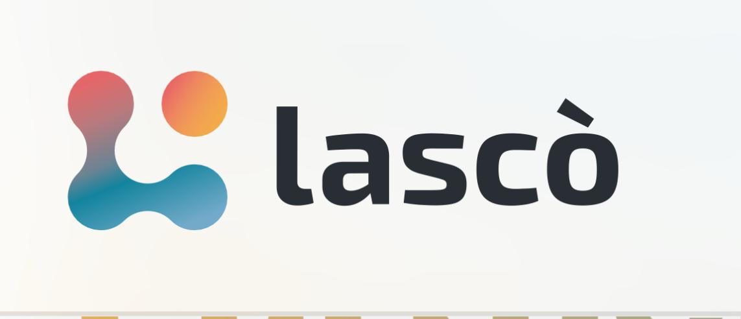

Profilo Lascò s.r.l.

Lascò is an Innovative SME specialising in human-centred innovation and digital transformation strategies for public and private organisations. With over a decade of experience, the company has developed expertise in system innovation, software engineering, and advanced technologies, including Blockchain (e.g., a Certified Good Practice by the Italian Ministry of the Interior for its blockchain-based system tracking and certifying a Made in Italy supply chain), Artificial Intelligence, Cloud Computing, and IoT (with solutions selected by the Italian Trade Agency to represent Italian innovators internationally).

MAIN AREAS OF ACTIVITY

• Innovation and Digital Transformation:

Lascò accelerates innovation and digital transformation processes for private and public organisations, designing bespoke projects, technologies, and solutions to support them in creating value for their target audiences. The company offers innovation design services, cutting-edge solutions, research and development, and technology transfer services.

• Education & Training:

As a member of the European Commission’s Pact for Skills, Lascò is dedicated to designing and delivering training experiences that foster upskilling and reskilling across Europe. The company provides opportunities for individuals—both young people and adults—to develop digital, green, and lifelong learning competencies. Lascò has successfully implemented numerous European projects funded by Erasmus+ and Horizon Europe, including two recognised as best practices by the United Nations Global Compact - Spanish Network for their contributions to SDGs 4 and 8. Furthermore, Lascò is a Core Member of the Digital Working Group of the European Commission’s Harnessing Talent Platform, leading the subgroup on skills for the green transition.

• Entrepreneurship & Innovation Support:

Through its Startup Builder, Lascò empowers entrepreneurs and innovative teams to refine and launch their innovation projects. It offers tailored mentoring, strategic guidance, and operational support to help turn ideas into impactful ventures. As promoters of the Caserta Chapter of Startup Grind - the global community powered by Microsoft for Startups and connecting over 4 million innovators across 125+ countries - Lascò actively fosters collaboration and knowledge exchange within the entrepreneurial ecosystem.